Visualizing and Predicting Heart Diseases with an Interactive Dash Board

Team ID: PNT2022TMID10044

Faculty Mentor: Team Leader : Sakthivel M

T K P Rajagopal Team Member : Sadhana M

Team Member : Sirisha G

Team Member : Sneha Bharathi V

# Dashboard Showing Different Types Of Visuals

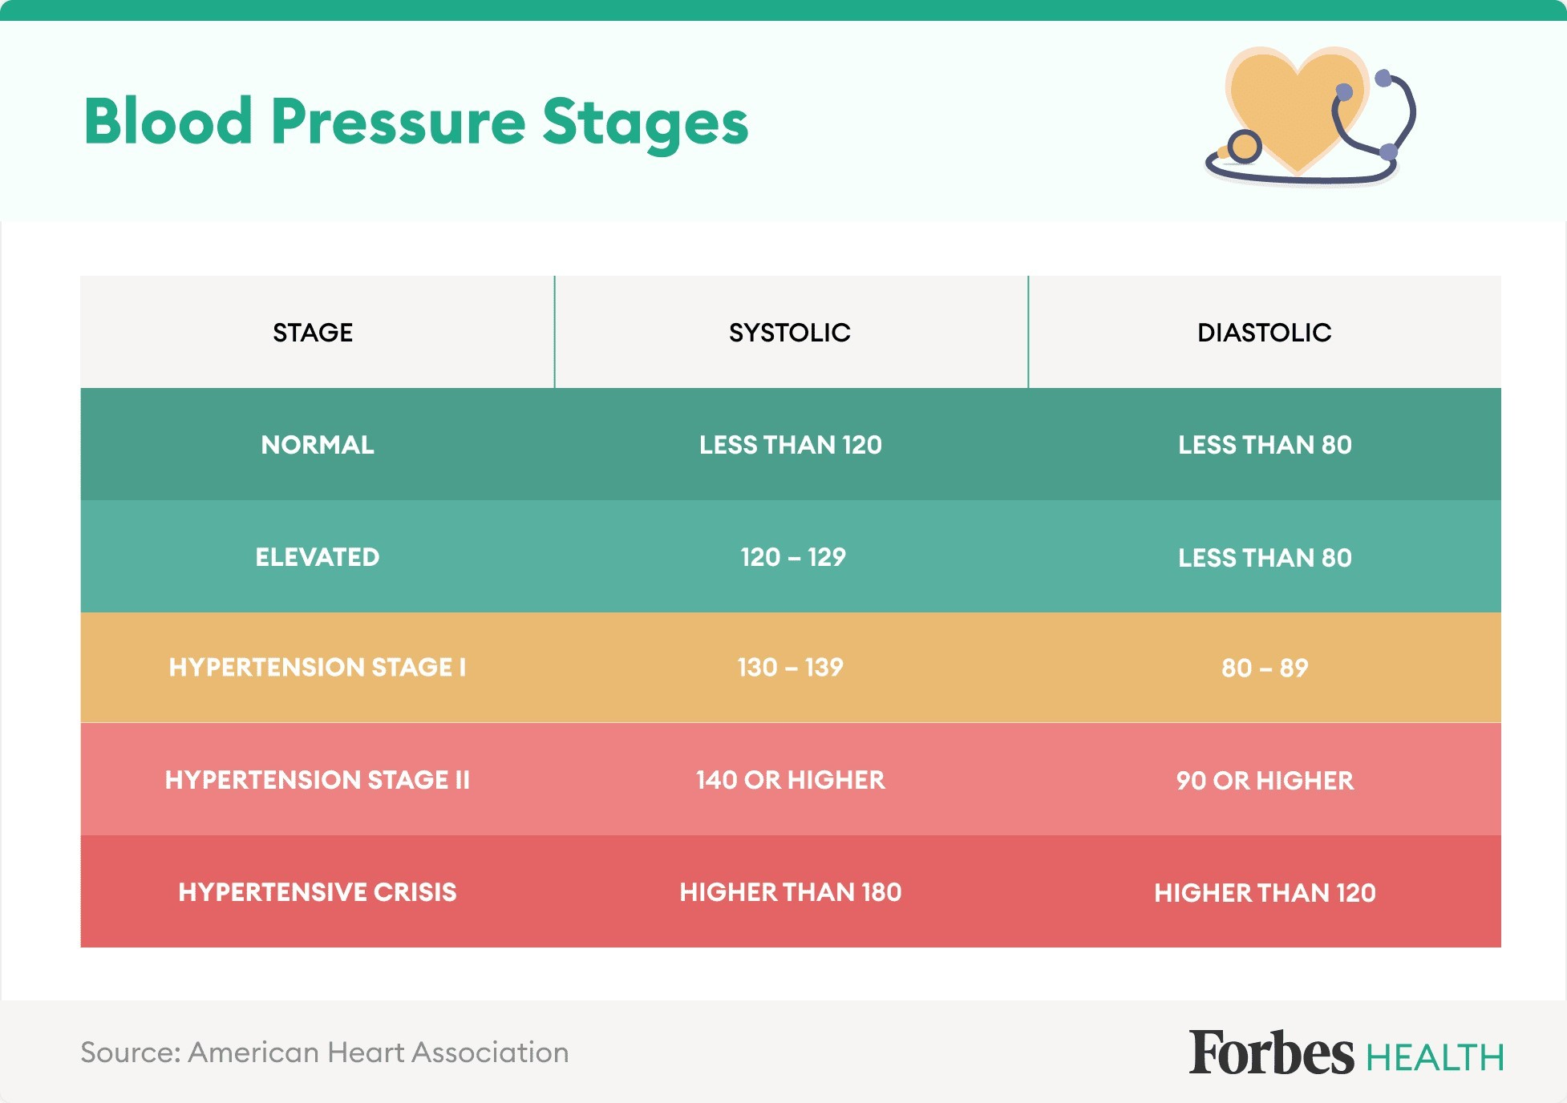

Normal Blood Pressure

People with a blood pressure range of 90 to 120 systolic and 60 to 80 diastolic have normal blood pressure, says Dr. Wong. A systolic reading below 90 signifies low blood pressure.

Elevated Blood Pressure

A blood pressure reading of 120 to 129 systolic and less than 80 diastolic signifies elevated blood pressure and, thus, a higher probability of developing hypertension.

“As blood pressure elevates, there is increased workload on the heart and arteries,” says Dr. Desai. “This results in [the] thickening of the heart muscle (hypertrophy), which can lead to heart failure. It also results in [the] micro-tearing of the artery wall, leading to cholesterol deposition (atherosclerosis). This leads to [the] narrowing of the vessel and further elevation of blood pressure.”

Hypertension Stage I

Hypertension Stage I is defined by a systolic reading of 130 to 139 and a diastolic reading of 80 to 89.

Dr. Wong says while doctors initially treat this stage of hypertension by suggesting a healthier lifestyle—eating more vegetables and whole grains, using less salt, increasing physical activity and controlling stress—medications may be needed if blood pressure falls in this range on multiple readings over a period of time in people with other cardiovascular risk factors.

Dr. Wong adds that, per 2017 ACC/AHA guidelines, adults with Hypertension Stage I should consider medication after three to six months of nonpharmacologic therapy. There’s also a risk of atherosclerosis—thickening or hardening of the arteries caused by a buildup of plaque in the inner lining of an artery—if it isn’t treated. Risk factors for atherosclerosis may include high cholesterol and triglyceride levels, high blood pressure, smoking, diabetes, obesity, physical activity and eating saturated fats.

1. Age: Age of subject
2. Sex: Gender of subject:
   1. = female 1 = male
3. Chest-pain type: Type of chest-pain experienced by the individual:

|  |  |  |  |
| --- | --- | --- | --- |
| 1 | = | typical | angina |
| 2 | = | atypical | angina |
| 3 | = | non-angina | pain |

4 = asymptomatic angina

1. Resting Blood Pressure: Resting blood pressure in mm Hg
2. Serum Cholesterol: Serum cholesterol in mg/dl
3. Fasting Blood Sugar: Fasting blood sugar level relative to 120 mg/dl: 0 = fasting blood sugar <= 120 mg/dl

1 = fasting blood sugar > 120 mg/dl

1. Resting ECG: Resting electrocardiographic results
   1. = normal
   2. = ST-T wave abnormality
   3. = left ventricle hyperthrophy
2. Max Heart Rate Achieved: Max heart rate of subject

|  |  |  |
| --- | --- | --- |
| 9. Exercise  0 = no 1 = yes | Induced | Angina: |

1. ST Depression Induced by Exercise Relative to Rest: ST Depression of subject
2. Peak Exercise ST Segment:
   1. = Up-sloaping
   2. = Flat
   3. = Down-sloaping
3. Number of Major Vessels (0-3) Visible on Flouroscopy: Number of visible vessels under flouro
4. Thal: Form of thalassemia: 3

3 = normal

* 1. = fixed defect
  2. = reversible defect.